**Local Database Set-up**

Requirements:

Microsoft .NET Framework 4.5

Microsoft Visual C++ 2015 Redistributable Package

1. Download msi installer from http://dev.mysql.com/downloads/windows/installer/
2. Install the msi installer and follow the steps
3. Choose the Standalone MySQL Server and select port 3306
4. If MySQL Workbench did not get installed, you can download it at: http://dev.mysql.com/downloads/workbench/ and install it.
5. MySQL Workbench can be installed using the Windows MSI Installer package. The MSI package bears the name
6. mysql-workbench-community-version-winarch.msi, where version indicates the MySQL Workbench version number,
7. and arch the build architecture (winx64).
8. For us, the MySQL Workbench was located at: C:\Program Files\MySQL\MySQL Workbench 6.3 CE. By default, it should install everything for MySQL under
9. C:\Program Files\MySQL. Go to the directory where MySQL Workbench is located.
10. Open MySQLWorkbench.exe
11. Click File tab -> Open Model
12. Select the database.mwb from our project at umbuy\project\umbuy\web\src\app\persistence
13. That should import our databases into your local MySQL Workbench for you to see.
14. We need to synchronize our database to localhost to be able to connect to it through express. Click Database tab -> Synchronize model
15. The only thing you need to change is the user name and password to match the user name and password you entered when you installed MySQL Server in step 2-3
16. Continue to push next until the dialog closes. Now your database should be running locally, and you should be able to connect locally.
17. You need to go to localhost.js in umbuy\project\umbuy\web\src\app\persistence and update:

var connection = mysql.createConnection({

host: ‘127.0.0.1’,

user: 'yourLocalMySqlUsername',

password: " yourLocalMySqlPassword",

database: 'project4350',

port: '3306'

);

1. 127.0.0.1 means localhost, change the user and password fields to match the username and password you chose for MySQL, the database name is shown in the screenshot below and port is 3306 which is the default. If you change the port while setting up MySQL, make sure to change port to that port number.

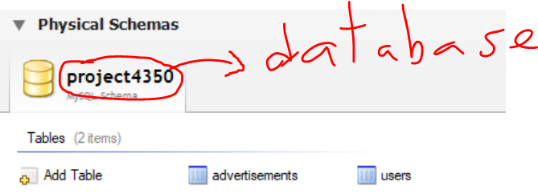

1. Now from the directory where localhost.js is located (umbuy\project\umbuy\web\src\app\persistence), in command line type: node localhost.js. You should get a message like below:

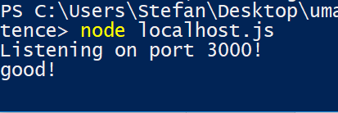

1. Now, you can test it out and refer to umbuy\project\umbuy\web\documentation\http_api_documentation.docx
2. **Important Note: You need to run node localhost.js and ng serve at the same time ( therefore 2 different command prompts or powershells).**
3. **CHECK: To make sure you set the database up correctly, do node localhost.js and then once you see the message as above, open your browser and type localhost:3000/api/ads and you should get [] since there is no data locally at first. If you have data from the previous snapshot, then it’s fine if you get data back as long as there is no error in the command line or browser. It should look like below if there is no data:**

**Database Setup for Mac**

For Mac users, setting up local database is really easy.

1. We are using MySQL so you need to install mysql. You can use almost any package installers, here I assume you use “homebrew” (if not, I highly recommend you to use it).

So, in terminal, do “brew install mysql” or equivalent

1. MySQL server might not be running after installation with Brew. So do “brew services start mysql” or “mysql.server start” (you might need to enter your password)
2. In terminal, do “mysql_secure_installation”, then follow the prompt the set up your password (other questions I said no, but yes will work as well)
3. Go to “umbuy/project/umbuy/database” where database.sql lives, do: mysql -u root -p -e “source database.sql”

This will create the database and table for project UMBUY running locally.